2nd quarter Review: 8.L.5.1 & 8.L.5.2 Name:
DO NOT WRITE IN COACH BOOK!!!
Part 1:
Directions: Read pages 60 – 62 in the Coach Book at your desk and answer the following questions.
- Compare and Contrast the two types of cells (prokaryote & eukaryote): Draw picture of each type of cell.

- Structure of Eukaryotic Cells:
Structure | Plant , animal, both | Function & illustration
Nucleus
Chromosomes
Cell Membrane
Ribosomes
Mitochondria
Vacuole
Chloroplast
Cell Wall

Turn to page 64 in Coach book and answer the multiple choice questions.
Questions | Answers | Questions | Answers
1 |  | 3
2 |  | 4

Part II: Energy and Matter for Cells
Directions: Read pages 65 – 67 in Coach Book at your desk and answer the following questions.

- Under the “Getting the Idea” section it talks about the importance of food. In your own words tell why organisms need food.

- Using the following picture of photosynthesis, explain how photosynthesis works: You must have the chemical formula , the two stages, and also the following vocabulary (chloroplast, carbon dioxide, glucose, cholorphyll, water, oxygen)

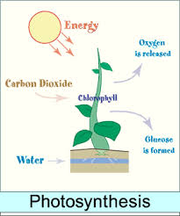

Cellular Respiration:
- Where do all organisms break down simple sugars for energy (make sure to mention prokaryotic and eukaryotic)?

- Using the following picture of cellular respiration, explain how cellular respiration works: You must have the chemical formula , and also the following vocabulary (oxygen, sugar, energy, carbon dioxide, water).

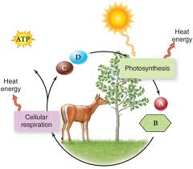

- Explain how humans get the oxygen needed for cellular respiration throughout the body.

- Our body converts the chemical energy released from cellular respiration into what over types of energy and shy?

Building Cells:
- What are the compounds that provide energy and building materials for living things called? _____________

How do plants use glucose?

Starches

Cellulose
Composed of:
Carbohydrates
Broken down ____________ to release energy

Proteins
Where do animals store fat?
Why is fat important?
Uses & importance
Lipids
Oil: describe state & where comes from
Fats: describe state & where comes from

Different types:

Composed of:
Importance of protein?
Where located in body and function?

Turn to page 68 in Coach Book and answer the multiple choice questions.
Questions | Answers | Questions | Answers
1 |  | 3
2 |  | 4

