Close Notes: Species Change over Time:

* Evolution:

________________- occur following a _____________ drastic change in the environment

If organisms don’t ____________ quickly enough to survive, they die

The extinction of a species can affect an __________ ecosystem

* + __________ that relied on the ___________ species for food may die
  + Species that once ___________ for food with the extinct species may thrive

Extinction is a ____________ part of evolution

Scientist s estimate that about __________ of all species that ever lived on Earth have become __________

On average a species will ___________ on Earth 2 to ______ million years

* Natural Events that cause Extinctions: ____________, rainfall, volcanic eruption, __________, flooding or drought, ________land masses or seas, a __________ in food supply, a new _________ or __________

Mass Extinctions:

**________________ Extinction**

* ________ million years ago species living in the ocean and on land became extinct because ________ _________ moved together which ________ the _________ of Earth

**______________ Extinction**

* ______million years ago _________ disappeared on Earth
* ___________Theory- at the rock layer between the Cretaceous and Tertiary periods evidence of an asteroid can be found

Human Threats for extinction:

|  |  |  |
| --- | --- | --- |
| Threat | Description | Remedy |
| Habitat |  | Reduce human encroachment –land management |
| Invaders | Non - native species introduced to new locations |  |
|  | Contaminated land, air, water |  |
| Overgrazing  Forest burning |  | Land use management |
| Overharvesting | Species taken for food, energy, medicine |  |
|  | Ozone depletion, greenhouse effect |  |
| Poaching, overhunting,  overfishing |  | Reduce demand, laws |

Answer the following questions from the video. Isn’t Evolution just a Theory?

* What is a theory?
* What is an inference?
* What was Charles Darwin’s theory?

**Natural Selection:**

Charles Darwin (1809-1882) Sailed around the world 1831-1836

What did __________ Travels reveal?

* The ____________ of living species was far ___________than anyone had previously known!!
* These observations led him to develop the _________ of ____________!!
* Based in part his evolutionary theory on observations of _________ species on the Galapagos Islands.
* ___________ species of finch had developed ___________ beak _________for the types of food that was available on the different islands
* Suggested that the ___________ species of finch had __________ from the original species in response to ___________ environmental conditions

How did tortoises and birds differ among the islands of the Galapagos?

* Each _________ had its ________ type of tortoises and birds that were clearly _________ from other islands

Artificial Selection:

* ____________ provides variations, ___________ select variations that are useful.

Natural Selection and Species Fitness:

* Over time, _________ selection results in changes in the ___________ characteristics of a population.
* These changes _________ a species fitness (survival rate)
* The traits that help an organism survive in a particular environment are “____________” in natural selection

Natural Selection:

Summary of Darwin’s Theory

|  |
| --- |
| 1. |
| 2. |
| 3. |
| 4. |
| 5. |

Theory of Natural Selection

* Darwin knew from personal experience that dog breeders can produce new species over time by selective breeding techniques. Breeding dogs with desired traits produces a new breed of dog. This process is called artificial selection.
* He thought this process might be ______________ occurring in nature and termed it natural selection

Key Principles of Natural Selection

* ___________________ - most organisms produce more offspring than can survive
* _______________ - visual differences among individuals result from differences in genetic material this process of changing base pairs in the DNA is called a mutation.

**________________ -** A trait that improves an organism’s chance for survival and reproduction.

**_______________**- The individuals that have the adaptation increase in numbers and are able to adapt to the environment over the individuals who do not have the adaptation

Homologous Body structures

Structures that have ___________mature forms but develop from the same embryonic tissues

*e.g. wing of bat, human arm, whale flipper, leg of cat*



**Analogous Structures** ­­­­­_______ different but essentially perform the ________ function for each organism

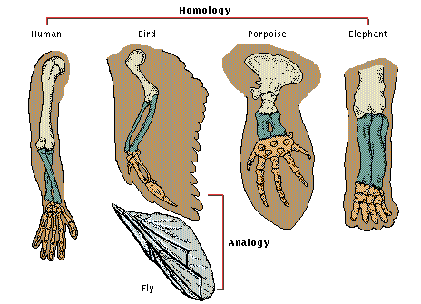

**Vestigial organs**- are __________ structures that were ________ developed and functional in an _________ group of organisms but are ___________ and ________in later species.

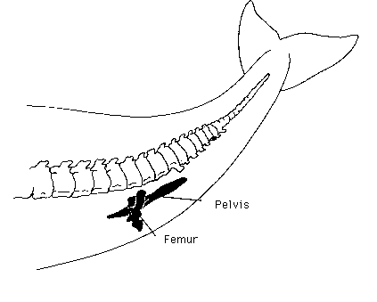

**Evidence of Evolution**

Geographic Distribution of Living Things

___________ animals in different l__________were the product of __________ lines of descent

Fossil Record

Fossil Record provides ___________ that living things have ___________

Fossils show the ___________ of ________ on earth and how ____________ groups of organisms have changed over time

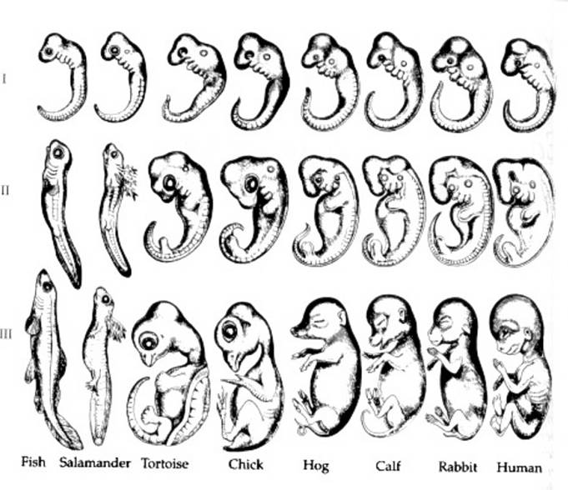

Similarities in Embryology

In their ________ stages of development, chickens, turtles and rats _______ similar, providing evidence that they _________ a common ancestry.

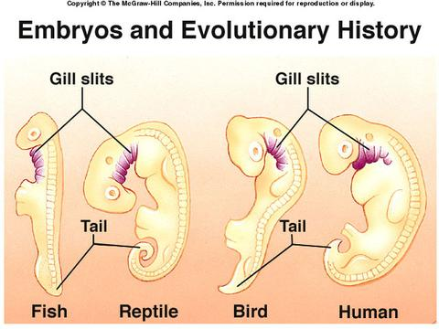

**Traces of homologous organs in other species**

**_________ that serves ______ useful function**

***Example: Appendix***

**Evolution and Speciation**

* ________ ________ – Common group of _______ genes present in a population.
* ____________ genetic info. of _________ members
* Allele frequency is # of times alleles occur

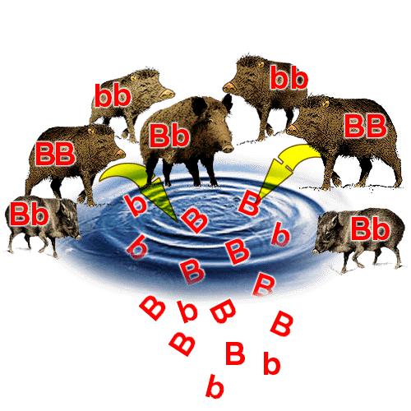

**Variation in Populations**:

2 processes can lead to this:

* ___________ -change in DNA sequence
* ________ __________ – from sexual reproduction

**Evolution of populations**: Occurs when there is a __________ in relative frequency of alleles

**Speciation**: The Formation of a _______ Species

* As new species evolve, ___________ become reproductively isolated.
* _________________ ___________ – members of 2 populations cannot interbreed and produce fertile offspring**.**

**Speciation in Darwin’s Finches**:

* Speciation of the Galapagos Finches occurred by:

- ___________________________________________________________________

- Geographic Isolation which led to – Reproductive isolation and

- Changes in the new population’s gene pool due to __________________.

