Closed notes – Earth’s history ppt
- _______________________ - The study of the EARTH, rocks, and fossils.
- ________________________ - The idea that the earth has been shaped by __________changes (erosion, deposition) throughout history. These changes are ________ occurring. James Hutton proposed this idea and wrote Theory of the Earth. The ___________ is the key to the __________. What’s going on _________ is what went on long ago
- _______________________ - Changes in the Earth happen suddenly through events called catastrophes!!
- ________ ____ _______________ : In ______________ rock layers, the _______________ layer is at the bottom. Scientists use this law to relatively date the sedimentary rock layers. Draw a picture to explain Law Of Superposition.

- Why is __________ rock always younger than any rock it cuts through? In order for the _________
rock to cut through rock ________, the rock ________ around it must have ________ before the ________ rock could cut through it.

Extrusion vs. Intrusion
- _______________ is an igneous rock layer formed when lava flows onto Earth’s surface and hardens.
- _______________is an igneous rock layer formed when magma hardens beneath the Earth’s surface.

Types of Unconformities
- _______________ -missing layer of rock in a sequence of parallel rock layers 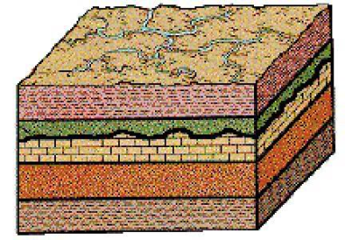

- ________________ -missing layer that exists between horizontal and folded rock layers
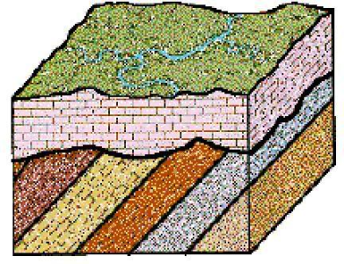
- _________________ - A break in a body of rock along which one block slides against the other
- _________________ - Fossils of _________ that were ___________ that lived in many areas and that existed only during __________ spans of time.
- This kind of fossil is important for figuring out when _________ __________ were formed

Relative dating v Absolute Dating
- ____________ ____________ - Using index fossils to compare the age of rocks works the same way!
- ____________ ___________ : finding the _________ date of rock or fossil using scientific processes
- _____________ ____________ is one way to do this. Finding the __________ of a substance means finding out how long it takes ½ of the radioactive isotopes (parent) to change to become stable (daughter).

Fossils

- ______________ - traces or remains of ___________ things from long ago. Takes many __________ such as shells, bones, and teeth. What allows this to happen? The _____________ replace the remains forming a fossil.
- _______________ __________ : Fossils that are the actual bodies or body parts of organisms are called original remains. They give __________ evidence of forms of life that lived long ago. Ice, amber, and tar have provided scientist this type of evidence
- _______________ _______________: Conditions have to be just right for a fossil to form in rock
- Must be ___________ before decomposition; Rock fossils mainly only have the _________ remains not the soft remains because the ________parts decompose to quickly. ; Form in ___________rock like sand or mud.
- _____________________ (describes rock formed under conditions of __________ heat or produced by the solidification of volcanic magma on or below the Earth's surface) ___________contain fossils because the heat from which the rock came from would have ____________ any fossil remains.

Not original remains, impressions or traces
- ___________ and _________ – organism dies and falls into soft sediment over time the sediment becomes rock and the organism decays, leaving a mold.

- ____________ ________- stone fossil of a tree. Water passes through the cells of the tree depositing minerals which take the place of the cells producing a stone likeness.

- _________ __________- visible carbon left behind by an organism these can show soft parts in organisms.

- __________ __________- preserved footprints, trails, animal holes, and feces these fossils allow scientist to infer about what animals ate how fast did they travel.

Ice Cores
- ________ ________- Tubular sample of ice shows layers of snow and ice built up over time. Scientists analyze ________trapped in the ice to learn how the __________ has __________. Differences in air content at different levels shows how much _________ went up and down over long periods of time.

Tree Rings
- ________ varies; Dry years- ________ rings; Wet years- __________ rings
- Helps to determine weather patterns from the past.

Geologic Time Scale
- Divides Earth’s history into ___________ of time defined by _________ events or changes on Earth._______________ – Earth’s history is divided into __________eons. Hadean , Archean, Proterozoic , Phanerozic (Current)
- __________ – Paleozoic , Mesozoic, and Cenozoic era are division of the Phanerozic eon.
- ________________ - eras are divided into periods
- ___________ - periods of the Cenozoic are divided into epochs.

Important Events in Earth’s Past
- _________ Mammals appear in the ________ Period of the Mesozoic era.
- __________ lived and became __________ during the Mesozoic era.
- ________ humans appear in the _________ era
.

