Guided Notes: 8.5.L. Transfer of energy through the ecosystems.

- 1) Understand the composition of various substances as it relates to their ability to serve as a ________ of energy and building materials for ________ and ________ of organisms

- 8L5.1: Summarize how food provides the _________ and the _____________ required for building materials, growth and survival of all materials for growth and survival of all organisms (to include plants)

___________ provides molecules that serve as fuel and building material for all organisms.

- ____________ use the energy in __________ to make sugars out of carbon dioxide and water.

- This food can be used ____________ for fuel or materials or it may be __________ for later use.

- Organisms that eat plants break down the plant structures to ____________ the materials and energy they need to survive. Then they are consumed by other organisms.
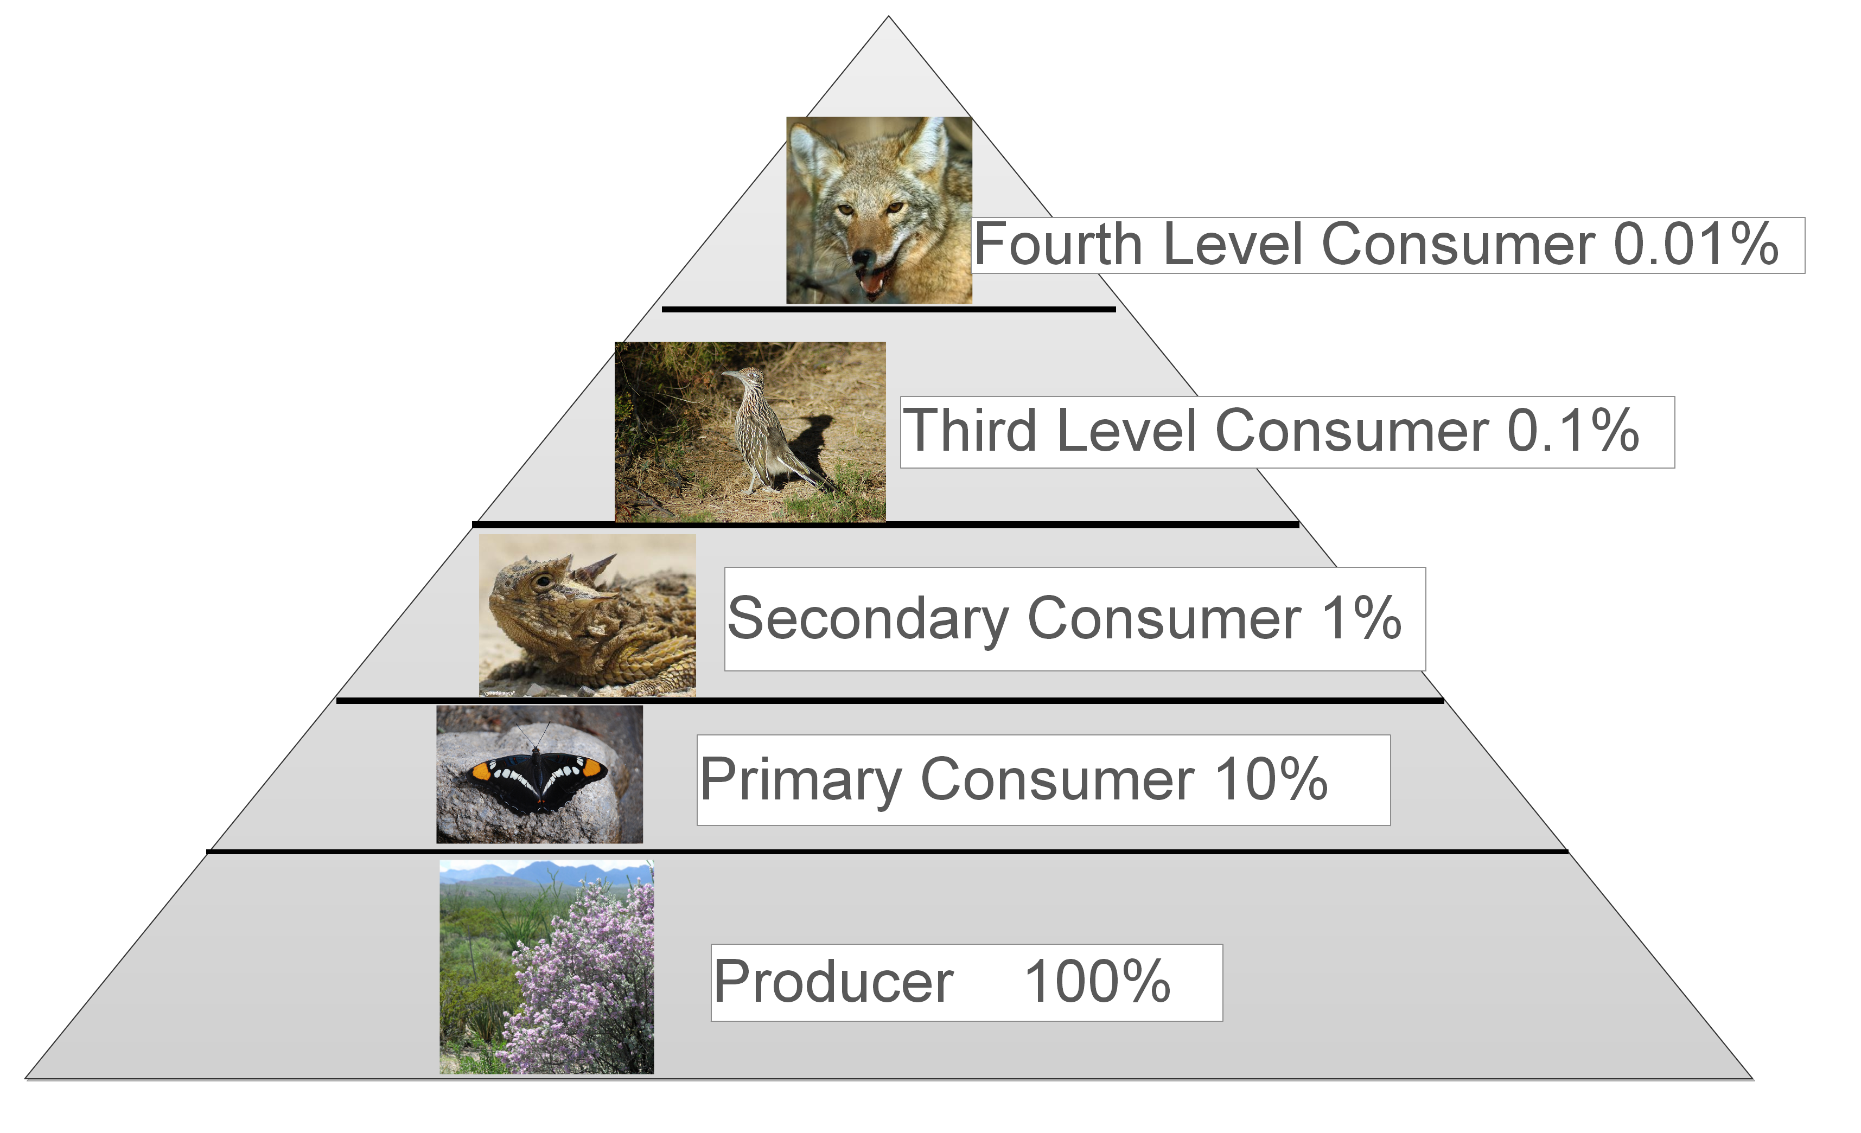

Photosynthesis
- Plants use the __________ from light to make sugars (food) from __________________ and ____________. This process _______________ light energy from the sun into stored ____________l energy.
- _______________ and other nutrients from the soil are not food (they don’t provide energy), but they are needed for plants to make complex _________________ from the sugar they make.

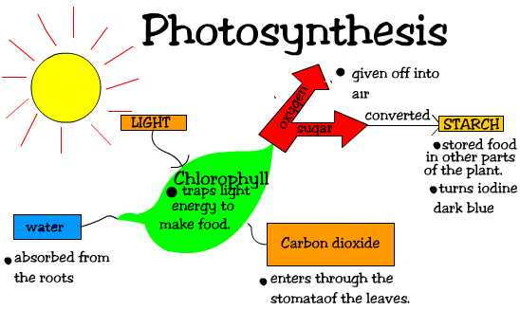

Conservation of energy
- Chemical energy is transferred from _________ organism in an ecosystem to _____________ as the organisms interact with each other for food.

- The _________ that make up the organisms in an _____________ are cycled ______________ between the living and nonliving parts of the ecosystem. Over a long period of time, _____________ is transferred from one organism to ____________ repeatedly and between organisms and their physical environment.

- As in all material systems, the _____________ amount of matter remains ________________, even though its form and location change.
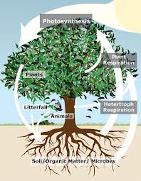

Cells carry on the many functions needed to sustain life.
- They ______________ and _____________ (mitosis or meiosis), thereby producing more cells.

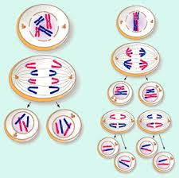

- This requires that they take in nutrients, which they use to _______________ energy for the work that cells do and to make the materials that a _________ or an organism needs.

- The way in which all cells function is ________________ in all living organisms. Within cells many of the ______________ functions of organisms, such as releasing energy from ___________ and getting rid of __________, are carried out by different cell elements.

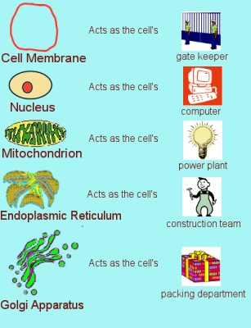

Matter is transferred among organisms in an ecosystem when organisms eat, or are eaten by others for food.
- Matter is ______________ from organisms to the ___________l environment when molecules from food __________ with oxygen to ________________carbon dioxide and water in a process called ______________________.
- Through the process of ____________________________, cells convert energy _________________ to a usable form of energy _________________
- The energy stored in ___________ provides the means by which cells are able to carry out their functions such as ______________, _________________, and ______________ of organisms, _____________________ and ___________________ of molecules across cell membranes.

Energy can change from one form to another in living things
- Animals get energy from ________________ their food, releasing some of its _______________ as heat.
- Almost all food energy comes originally from ___________________.
- In plants and animals, _________________ from food (a) react with ______________ to provide energy that is needed to carry out life functions, (b) _____________ and become incorporated into the body structure, or (c) are ________________ for later use. (Also in Matter and Energy)
- _______________ moves within individual organisms through a series of __________________ _______________ in which food is broken down and _________________ to form new molecules

