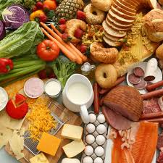
“Harvest of Fear”

Video Worksheet One

Name _______________________________ Date ___________

Introduction

1. What is The E.L.F.?

2. What devastated the Papaya crop in Hawaii?

3. How did the researchers possibly solve this problem?

4. What was one of the early genetic modifications for corn?

5. What school is at the center of Agricultural Research?

6. How is the "natural fiber" cotton a problem for the environment?

7. What are GMO's?

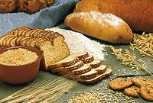
“Harvest of Fear”

Video Worksheet Two

Name _______________________________ Date ___________

Are GMO’s Safe to Eat?

1. Why do most GMO’s not need to be labeled?

2. Who are the…

USDA?

FDA?

EPA?

3. Why are allergies an issue with GMO’s?

4. What is main issue behind the "Starlink" corn?

5. How did "Starlink" corn, meant only for animal consumption, end up in food produced for humans?
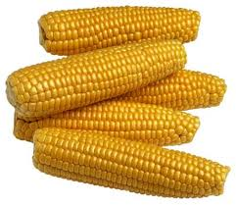

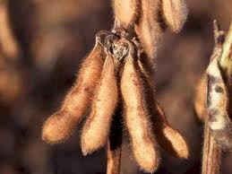
“Harvest of Fear”

Video Worksheet Three

Name ____________________________ Date ___________

Are we tampering
with nature?

- What types of risks can conventional plant breeding cause?

- What are two major differences between conventional breeding and genetic engineering?

- Would the strawberries actually smell like fish?

- What steps did the papaya farmers have to take before being able to sell the papaya into the human food chain?

- What was one last issue that stood in the way of this papaya?

- Do you agree with companies having a patent on genetics?

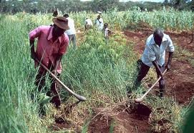
“Harvest of Fear”

Video Worksheet Four

Name ____________________________ Date ___________

Do GMO’s damage the environment?

- What role did the monarch butterfly play in America’s view of GMO’s?

- How could discontinued use of GM crops, such as BT corn or cotton, actually cause more damage to the environment?

- What is Organic Farming?

- What is the resistance problem?

- Who was Norman Borlaug?

Do we need GMO’s to feed the world?

- Are GMO’s needed to feed people in America? How about feeding people in developing countries?

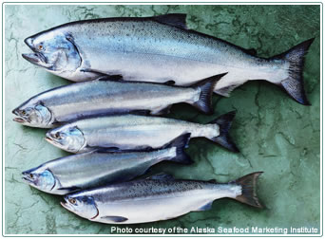
“Harvest of Fear”

Video Worksheet Five

Name ____________________________ Date ___________

What does the future hold?

- What are the positives behind the GM Salmon?

- What are the negatives behind GM Salmon?

- What is the story behind the GM banana?

- What is the advantage of golden rice?

- Why is the biotech industry afraid of labeling GMO's?

Personal Reflection and conclusion

How do you feel about GM foods? Do you have overall positive or negative feelings and why?

Do you see a difference between allowing modifications that add medicine into plants VS allowing modifications that create resistance to a particular pesticide? Why?

Is there a difference between making plant-to-plant modifications VS insect/animal to plant modifications? Why?

