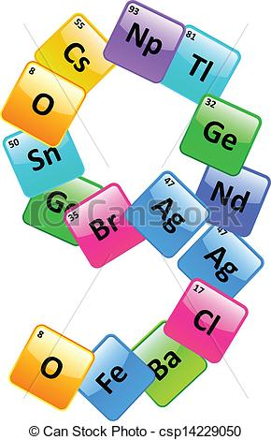Investigative Infographic
Name: _____________________________________
Core: __________________________
Teacher: _______________________
In this investigation, you will create an infographic for a specific element of your choice. You will create the infographic on easel.ly.com which is a site to create artistic infographics. You will need to register on this site with an email and create an account for yourself. Your final product should be emailed to your instructor.
What is an Infographic?A well-designed infographic like the one below can help you simplify a complicated subject or turn an otherwise boring subject into a captivating experience. Adding interactive content like can be one of the most effective strategies in portraying information to an audience. Ideally, an infographic should be visually engaging, contain a subject matter that is appealing to your target audience, and be supported by other related engaging content.
https://www.customermagnetism.com/wp-content/uploads/2012/11/light-bulb-infographic.jpg
View this infographic by clicking on the above link.
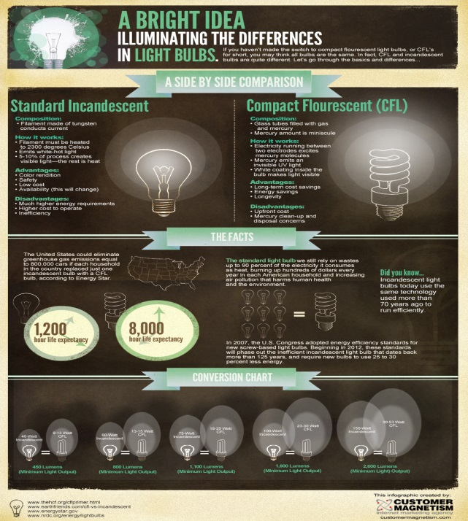
Criteria for your Infographic:
- Centers around a specific element from the periodic table
- Includes the characteristics of the element (its properties, family, reactivity, group, etc.) and an explanation of relationships that exist for this element to others in its family and period.
- Visuals of the element in its molecular form and other visuals
- Discovery information for this element
- Connections and relationships of this element to our world- how this element is used in the real world.
- Benefits and detriments of this element in our global society.
- Other interesting details. Include at least 5.
- Creative and logical layout of the information in a format that is clear to follow.

