Station 1: Density Practice
Directions: Complete the density problems at this station using the formula for density (D = Mass/Volume) and the equipment provided. Make sure you show your work. Please record all work and answers on your data sheet.

- What is the equation for density?

- An object has a mass of 35.7 grams and a volume of 6.23 cm³. What is its density?

- Exactly 53 mL’s of water is measured out in a graduated cylinder. An object is submerged in the water. The level of the water rises to 71 mL’s. The mass of the object is 207.4 grams. What is its density?

- Different substances and their densities are listed in the table below. Which substances will float in a glass of salt water which has a volume of 100.6mL and a mass of 175 grams?
Substance | Density (g/mL)
Ice | 0.92
Corn Oil | 0.93
Corn Syrup | 1.38
Salt | 2.16

- An object has a mass of 257 grams and a density of 2.5g/cm³. What is the volume of the object?

- Using the equipment provided, find the density of the block.

Station 2: Is it Matter?

Directions: Answer the question below regarding matter.

- What is the definition of matter?

- Pick 5 items on the list below that are matter and 5 items that are not matter.

- Rocks
- Baby Powder
- Milk
- Air
- Light
- Dust
- Energy
- Love
- Cells
- Thoughts
- Atoms
- Fire
- Smoke
- Dreams
- Salt
- Mars
- Steam
- Rotten Apples
- Heat
- Water
- Bacteria
- Sound Waves
- Oxygen
- Gravity
- Stars
- Magnetic Force
- Electricity
- Dissolved Sugar

- Look at the pictures below. Complete the table on your answer sheet.
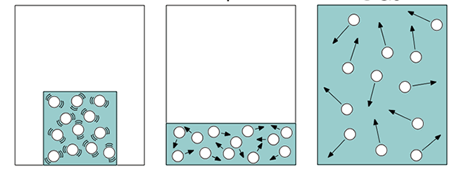
C
B
A

Station 3: Elements, Compounds, and Mixtures

Directions: Answer the question below regarding elements, compounds, and mixtures.

- What is an element? Example?

- What is a compound? Example?

- What are the two types of mixtures and how are they different from each other?

- Label the diagrams below using the word bank. Record your answers on your data sheet.
- Element B. Element Mixture C. Compound
D. Compound Mixture E. Element and Compound Mixture

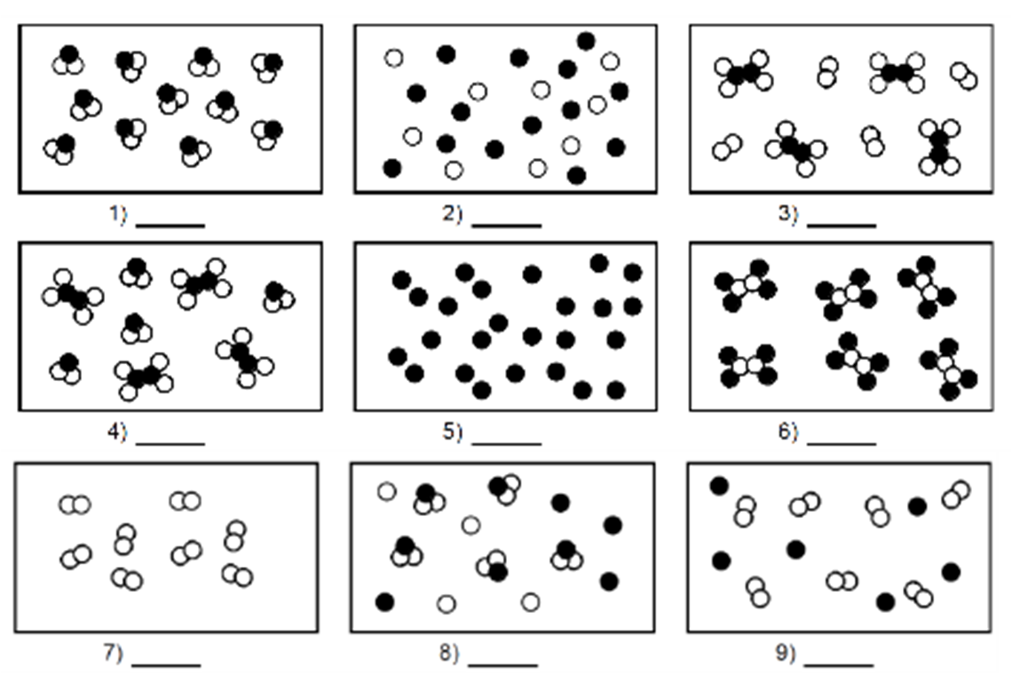

Station 4: The Law of Conservation of Matter

Directions: Use the diagram to answer the question below. Then decide which equations satisfy the law of Conservation of matter. Record all your answers on your data sheet.
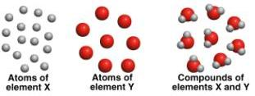
- Please explain how the diagram above satisfies the Law of Conservation of Matter?

- Which of the following reactions illustrates the Law of Conservation of Mass?
  - 2H₂O₂ 2H₂O + O₂
  - 3Na₂SO₄ + 2AlPO₄ Al₂(SO₄)₃ + 2Na₃PO₄
  - N₂ + H₂ 2NH₃
  - Na + CuS Na₂S + 2Cu
  - 2O₃ 3O₂
  - 2K + AgCl KCl + Ag
  - Zn + 2HCl ZnCl₂ + H₂
  - Li₂HPO₄ + Pb(NO₃)₂ 2LiNO₃ + PbHPO₄
  - NaOH + 2HCl NaCl + H₂O
  - Fe₂O₃ + 2CO 2Fe + 3CO₂

- A chemical reaction occurs where 20 grams of 2NaOH and 23 grams of 2HCl chemically combine to produce 41 grams of 2NaCl and how many grams of 2H₂O?

- What mass (in grams) of Oxygen (O₂) is required for this reaction to occur?
CH₄ + 2O₂ CO₂ + 2H₂O
16g + _?_ 44g + 36g

Station 5: Equation Practice

Directions: Use the four equations below to answer the following questions about chemical reactions. Please record your answers on your data sheet.

Equation 1: H₂SO₄ + Al₂CO₃ + ENERGY Al₂SO₄ + CO₂ + H₂O
Equation 2: NaOH + 2HCl + ENERGY 2NaCl + 2H₂O
Equation 3: 4Fe₂ + 3PO₂ 2Fe₂O₃ + Fe₃P₂ ENERGY
Equation 4: 6CO₂ + 6H₂O + ENERGY C₆H₁₂O₆ + 6O₂
- List the reactants for Equation 2.

- How many Phosphorus atoms are on the reactant side of Equation 3?

- How many Oxygen atoms are on the product side of Equation 1?

- Which of the equations above are exothermic?

- Which of the equations above are endothermic?

- Which equations above satisfy the Law of Conservation of Matter (aka are balanced)?

Directions: Fill in the blanks below with a coefficient to make a balanced equation which satisfies the Law of Conservation of Matter.

- _____ Fe + _____ Cl₂ _____ FeCl₃

- _____ HgO _____ Hg + _____ O₂

- _____ Cu + _____ AgNO₃ _____ Cu(NO₃)₂ + _____ Ag

- _____ Zn + _____ HCl _____ ZnCl₂ + _____ H₂
Station 6: Physical Change vs. Chemical Change

Directions: Use the website on the computer at this station to take a quiz determining which of the following scenarios are Chemical Changes and which are Physical Changes. Make sure you record your answers on your data sheet.

http://www.quia.com/quiz/303980.html

Station 7: Physical Properties vs. Chemical Properties

Directions: Organize the words in the envelope by separating all chemical properties and physical properties. Then match up the definitions with the appropriate property. Next, match an example with each property and definition. Every property should only have 1 definition and 1 example. There is nothing to record for this station but when you are done make sure Mr. Shillinglaw checks your work to make sure it is correct.

CHEMICAL PROPERTIES
Toxicity
A measure of how much a substance can damage a particular organism.
Ex: Lead (Pb), Uranium (U)
Flammability
The ability to burn.
Ex: Hydrogen Gas
Reactivity
How likely an element is to undergo a change; usually by combining with other elements.
Ex: Fluorine and Francium

PHYSICAL PROPERTIES
Density
The amount of mass contained in a given volume.
Ex: 200 grams/50cm³ = 4g/cm³
Malleability
The ability to be hammered into a thin sheet.
Ex: Aluminum (Al)
Ductility
The ability to be pulled into a long wire.
Ex: Copper (Cu)
Conductivity
The ability to transfer heat or electricity.
Ex: Metals
Solubility
The ability of a substance (solute) to dissolve into another substance (solvent).
Ex: NaCl in H₂O
Specific Heat
The amount of energy needed to raise the temperature of a substance by 1ºC.
Ex: H₂O’s is VERY high

Station 8: Periodic Table Practice

Directions: Use the periodic table to answer the following questions. Make sure you record your answers on your data sheet.

- What is an element with properties similar to Manganese?

- What element is found in the fourth period and 14th family?

- How many valence electrons does Boron have?

- What is the most reactive metal and the most reactive nonmetal on the table?

- What is an element that is inert?

- Answer the following statements about the element Strontium.
  - Atomic #:

  - Atomic Mass:

  - # of Protons:

  - # of Electrons:

  - # of Neutrons:

  - # of Valence Electrons:

  - Metal, Nonmetal, or Metalloid:

  - Period #:

  - Family Name:

Station 9: Atoms and the Periodic Table

Directions: Label the pictures below with the appropriate words without a word bank. Make sure you record your answers in your data sheet.

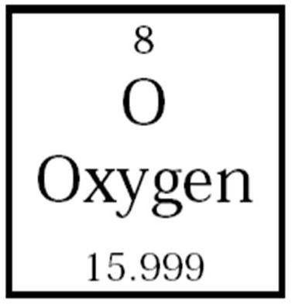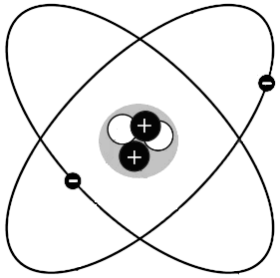
H.
G.
F.
E.
D.
C.
B.
A.

Directions: Put the following items in order from largest in size to smallest in size.

- Atom
- Electron
- Proton
- Nucleus
- Watermelon

____________ ____________ ____________ ____________ ____________
Largest Smallest

Directions: Draw the Bohr Model and Lewis Dot for the element Argon.

